**LICENSE PLATES**

Let a standard license plate consist of three capital letters and a 4-digit number - **ABC 1234**. It is required to develop a program that displays the next license plate after the entered one. For example, if the license plate is **ABC 1234** at the input of the program, then the output is **ABC 1235**.

Most often, you just need to add 1 to the numerical part of the license plate. However, if the input is **BAD 9999**, then the output is **BAE 0000** and is the next license plate in the sequence if all license plates are listed alphabetically.

The task becomes somewhat more complicated if the numerical part of the license plate is **9999** and the plate contains the letter **Z**. For example, if the input is **JAZ 9999**, the output will be **JBA 0000**.

The license plate **ZZZ 9999** is a special case because it is not followed by any license plate. In this case, you just need to display the message **"The last one"**, informing that this is the last possible license plate.

Write a program that, given the entered license plate, determines the next license plate and displays the result in the following format: **XYZ 9999 ==> XZA 0000.**

Test your solution with the following examples:

| Input | **==>** | Output |
| --- | --- | --- |
| ABC 1234 | **==>** | ABC 1235 |
| XYZ 9999 | **==>** | XZA 0000 |
| XYZ 9980 | **==>** | XYZ 9981 |
| BZZ 9999 | **==>** | CAA 0000 |
| ZZZ 9999 | **==>** | The last one |
| PQR 9999 | **==>** | PQS 0000 |
| AAA 0000 | **==>** | AAA 0001 |

**Дополнительно:** Implement file I/O to test the developed program. The input data file "input_1.txt" has the following format: the first line of the file contains the phrase "Plate Numbers"; the following lines of the file contain license plates (one per line) - three capital letters followed by one or more spaces followed by a non-negative integer (less than 10000).

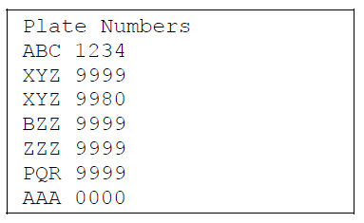

The output file "output_1.txt" should contain a list of input and output license plates. Формат выходного файла:

* header line that contains your name:

**Programmer: <put your name here>**

* empty line
* list of license plates in the format: **XYZ 9999 ==> XZA 0000**
* the numeric part of the plate must be printed with leading zeros if necessary: **0001**
* the following lines should contain a list of license plates that do not match the given format: **Invalid ==> xyz 999**
* empty line
* the last line must contain the number of processed license plates.

